Create a React Application named “officespacerentalapp” which uses React JSX to create

elements, attributes and renders DOM to display the page.

Create an element to display the heading of the page. Attribute to display the image of the office space

Create an object of office to display the details like Name, Rent and Address. Create a list of Object and loop through the office space item to display more data.

To apply Css, Display the color of the Rent in Red if it’s below 60000 and in Green if it’s above

60000.

Output:

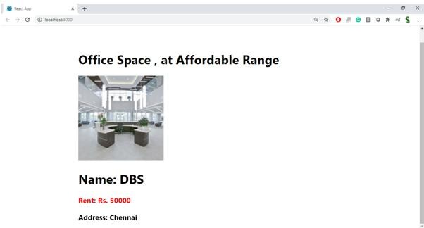

**Hint:**

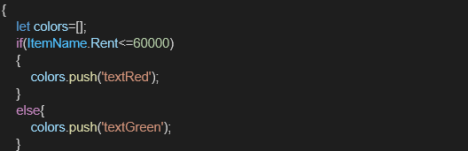

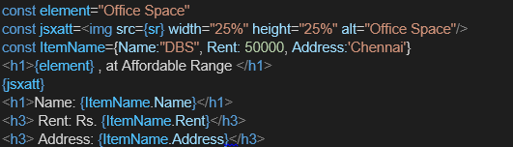

# OfficeSpaceList.js

import React from 'react'; import './OfficeSpaceList.css';

function OfficeSpaceList() { const heading = "Office Space";

const imageSrc = "https://images.unsplash.com/photo-1600585154340-be6161a56a0c"; // Sample image URL

const offices = [

{ Name: "DBS", Rent: 50000, Address: "Chennai" },

{ Name: "WeWork", Rent: 75000, Address: "Bangalore" },

{ Name: "Regus", Rent: 65000, Address: "Hyderabad" },

{ Name: "SmartWorks", Rent: 58000, Address: "Pune" },

{ Name: "Awfis", Rent: 85000, Address: "Mumbai" },

];

return (

<div>

<h1>{heading}, at Affordable Range</h1>

<img src={imageSrc} width="25%" height="25%" alt="Office Space" />

{offices.map((item, index) => {

const rentClass = item.Rent <= 60000 ? "textRed" : "textGreen";

return (

<div key={index} className="officeCard">

<h2>Name: {item.Name}</h2>

<h3 className={rentClass}>Rent: Rs. {item.Rent}</h3>

<h3>Address: {item.Address}</h3>

</div>

);

})}

</div>

);

}

export default OfficeSpaceList;

# OfficeSpaceList.css

.officeCard {

border: 1px solid #ccc; padding: 15px; margin: 10px;

border-radius: 8px; width: fit-content;

background-color: #f9f9f9; gap: 20px;

justify-content: center; display: flex;

}

.textRed { color: red;

}

.textGreen { color: green;

}

# App.js

import React from 'react'; import './App.css';

import OfficeSpaceList from './OfficeSpaceList';

function App() { return (

<div className="App">

<OfficeSpaceList />

</div>

);

}

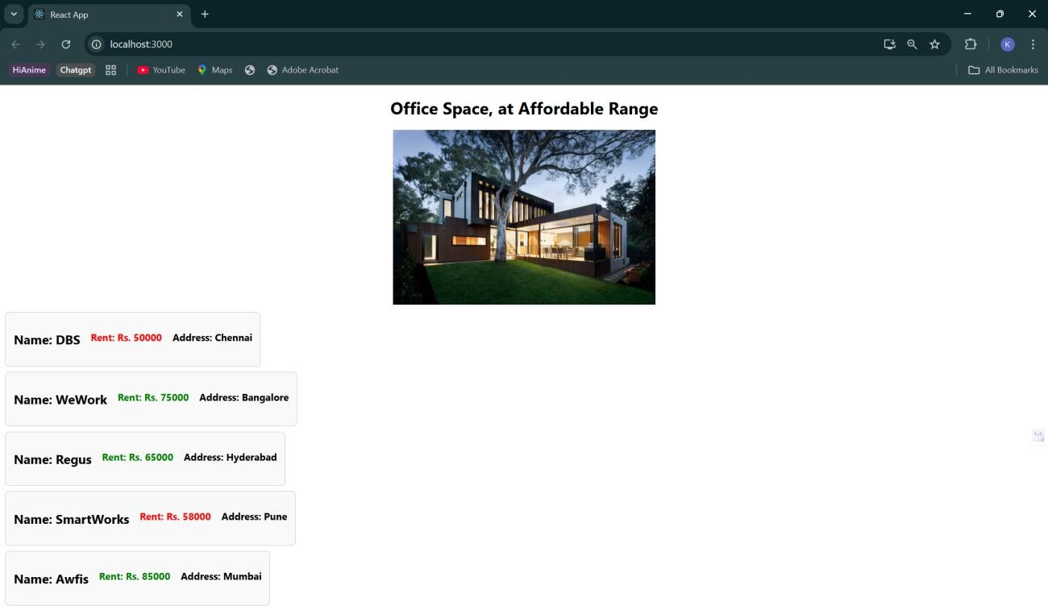export default App;